

**Parallelization of Sequence Comparison Algorithm for High Volume Data Processing**

**A PROJECT REPORT**

*Submitted by*

**LAKSHJEET PANDIT**

Course Title: Parallel Distributed and Computing

**VIT, Vellore.**

**SCHOOL OF COMPUTER SCIENCE AND ENGINEERING**

**April, 2023**

|  |  |  |  |
| --- | --- | --- | --- |
|  | **INDEX** |  |  |
| **Content** |  |  | **Page No.** |
| 1. Abstract |  |  | 3 |
| 2. Keywords and Objectives |  |  | 3 |
| 3. Problem Statement |  |  | 4 |
| 4. Methods and Features |  |  | 4 |
| 5. Performance Metrics |  |  | 5 |
| 6. Introduction |  |  | 6 |
| 7. Literature Survey |  |  | 6 |
| 8. Motivation and Justification |  |  | 16 |
| 9. Team Contribution |  |  | 16 |
| 10. Outline of Work (Architecture Diagram) | |  | 17 |
| 11. Algorithm and Technical Specification | |  | 18 |
| 12. Procedure | |  | 20 |
| 13. Proposed System | |  | 20 |
| 14. Methodology | |  | 21 |
| 15. Novelty (Technical and Mathematical) | |  | 22 |
| 16. Performance Evaluation | |  | 24 |
| 17. Result Analysis | |  | 25 |
| 18. Conclusion | |  | 26 |
| 19. Future Work | |  | 27 |
| 20. Code Implementation | |  | 27 |
| 21. Output (Serial and Parallel) | |  | 49 |
| 22. References | |  | 53 |

# ABSTRACT

The genome sequencing problem is one of the major issues for researchers regarding optimized system models that could help in increasing efficiency without bringing overheads in terms of memory and time. Bioinformatics and computational biology, being a multidisciplinary field, which explains many aspects of the fields of computer science with respect to the study of biology, can be applied in our project to predict the origin of viruses.

The sequence comparison of genomes helps in detecting similar parts between the query sequence and the reference sequence using two approaches, namely, global, and local alignment. In our project, we would be implementing the Smith-Waterman algorithm for local sequence alignment and compare the serial and parallel implementation.

The rapid increase of genome data brought by gene sequencing technologies poses a massive challenge to data processing. To solve the problems caused by enormous data and complex computing requirements, researchers have proposed many methods and tools which can be divided into three types: big data storage, efficient algorithm design and parallel computing. The purpose of this review is to investigate popular parallel programming technologies for genome sequence processing. Three common parallel computing models are introduced according to their hardware architectures, and each of which is classified into two or three types and is further analyzed with their features.

The comparison of the former analysis can be used to predict the origin of the viruses as the DNA alignment of the viruses can be similar as the DNA alignment of their origin.

# KEYWORDS

Genome sequence processing, parallel computing, Smith Waterman(S-W), Deoxyribonucleic acid(DNA), Severe acute respiratory syndrome-related(SARS), Coronavirus(CoV), Field Programmable Gate Array(FPGA)

# OBJECTIVE

In our project, we would be applying the Smith-Waterman algorithm for local sequence alignment and compare the serial and parallel implementation. The comparison of the former analysis can be used to predict the origin of the viruses as the DNA alignment of the viruses can be similar as the DNA alignment of their origin.

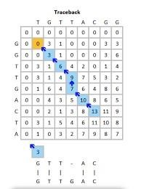

# PROBLEM STATEMENT

In the existing system for local alignment for gene sequencing, a sequential process is followed to implement the Smith Waterman algorithm. This process consumes a lot of time when the size of the data is huge. With the advancement in biotechnology, it is mandatory that we must be equipped ourselves to process more information as the data being recorded is increasing day to day. Therefore, we would be parallelizing the for loops which are used to compute the matrix using openMP and openMP+simd constraints. This helps us reduce the execution time.

# METHODS

There are several methods for genome sequencing that utilize parallel programming, which allows for faster and more efficient processing of large amounts of data. Here are some of the most commonly used methods:

1. **Next-Generation Sequencing (NGS):** NGS is a high-throughput sequencing method that uses parallel processing to generate millions of short sequences simultaneously. The sequences are then assembled into a complete genome using computational tools.

1. **Distributed Sequence Assembly:** This method uses a parallel computing architecture to distribute the sequence assembly process across multiple computers. This can significantly reduce the time required to assemble a genome.

1. **Parallel Genome Assembly:** In this method, the genome is divided into smaller fragments, which are then processed in parallel. This can increase the speed and accuracy of the assembly process.

1. **Parallel Mapping:** This method uses parallel processing to map the reads from NGS to a reference genome. This can be useful for analyzing variations in the genome, such as mutations and structural variations.

1. **Cloud-Based Genome Sequencing:** This method utilizes cloud computing resources to process large amounts of NGS data in parallel. This can provide access to highperformance computing resources for researchers and organizations that may not have the necessary hardware and software in-house.

These are some of the most commonly used methods for genome sequencing using parallel programming. The choice of method depends on the specific requirements and goals of the project, as well as the availability of computing resources.

# FEATURES

1. **Speed:** Parallel processing allows for the simultaneous processing of large amounts of data, which results in significantly faster sequencing times compared to traditional, sequential methods.

1. **Scalability:** Parallel processing methods can be easily scaled to accommodate larger sequencing projects or to process multiple genomes in parallel.

1. **Cost-Effectiveness**: Parallel processing methods allow for more efficient use of computing resources, which can reduce the overall cost of genome sequencing projects.

1. **Accuracy:** Parallel processing methods can increase the accuracy of genome sequencing by enabling the use of multiple algorithms and approaches to validate results.

1. **Data Management:** Parallel processing methods can facilitate the management and analysis of large amounts of genomic data by utilizing distributed computing resources.

1. **Collaboration:** Parallel processing methods can enable collaboration between multiple researchers and institutions, allowing for the pooling of resources and expertise to tackle large-scale sequencing projects.

# PERFORMANCE METRICS

1. **Speedup**

Speedup is a measure of performance. It measures the ratio between the sequential execution time and the parallel execution time.

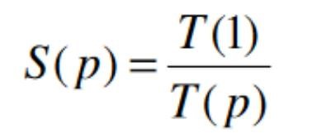

T(1) is the execution time with one processing unit. T(p) is the execution time with p processing units.

1. **Efficiency**

Efficiency is a measure of the usage of the computational capacity. It measures the ratio between performance and the number of resources available to achieve that performance.

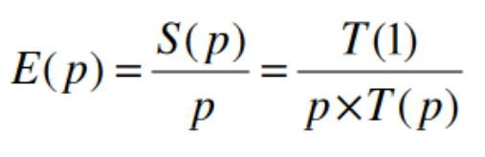

S(p) is the speedup for p processing units

1. **Redundancy**

Redundancy measures the increase in the required computation when using more processing units. It measures the ratio between the number of operations performed by the parallel execution and by the sequential execution.

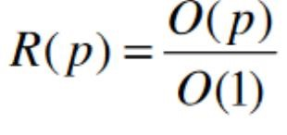

O(1) is the total number of operations performed by one processing unit O(p) is the total number of operations performed by p processing units

1. **Utilization**

Utilization is a measure of the good use of the computational capacity. It measures the ratio between the computational capacity used during parallel execution and the capacity that was available.

# INTRODUCTION

This J-component project focuses on the use of parallel programming in genome sequencing. The research introduced seven parallelism motifs that have been classified in previous studies across multiple journals and publications and also reviews hardware and software supporting parallel genome analysis. GPU-based parallel computing is introduced as a method in the fields of bioinformatics, computational biology, and systems biology.

The functions of various tools supported by GPUs, such as sequence alignment and molecular dynamics are discussed. Some of the latest models developed and published under research include MapReduce-based software and projects in next-generation sequencing (NGS) data processing, including sequence alignment, mapping, assembly, gene expression analysis, and SNP analysis. The focus on parallel computing in detecting epistasis of genome data and different computational methods and the tools used in each method is also an open research discussion.

Genome sequence processing is the most common operation in parallel computing as the input data can be divided into multiple parts and processed separately. However, there are many factors to consider to obtain efficient parallel computing as different memory, network, and I/O features lead to different computing performance. This review aims to help users choose suitable parallel computing models or tools for their data processing.

The three most popular parallel programming models in genome sequence processing are multicore computing, cluster computing, and heterogeneous computing. Each of these models has its particular features and are described in detail. The review also summarizes the main steps that adopt parallelized strategies for four common scenarios in genome sequencing: genome sequence alignment, SNP calling, genome sequence preprocessing, and pattern detection and searching.

# LITERATURE SURVEY

1. **Title:** GSAlign: an efficient sequence alignment tool for intra-species genomes

**Author & Year:** Hsin-Nan Lin & Wen-Lian Hsu (2020) **Method:**

|  |  |
| --- | --- |
| Personal genomics and comparative genomics are becoming more important in clinical practice and genome research. Both fields require sequence alignment to discover sequence conservation and variation. Though many methods have been developed, some are designed for small genome comparison while some are not efficient for large genome comparison. Moreover, most existing genome comparison tools have not been evaluated the correctness of sequence | |
| alignments systematically. | The future of the method proposed involves the requirement of more |

data sets on genome sequences in order to make large sets of comparisons, ultimately leading to the development of a genome-sequencing tool with ultra-fast alignment and high accuracy. The performance metrics taken into consideration are Small insertions and deletions (INDELs), Single-nucleotide variants (SNVs), Runtime (min), and Memory Usage (GB). The result of the proposed method is that the GSAlign tool requires a significantly less amount of memory compared to hash table-based or tree-based aligners. Additionally, GSAlign supports multithreaded computation, making it highly efficient when comparing large genomes. The tool produces perfect or nearly perfect precision and recall results in the identification of sequence variations for most of the datasets.

1. **Title:** A review on genetic algorithm: past, present, and future

**Author & Year:** Sourabh Katoch & Sumit Singh Chauhan & Vijay Kumar (2021) **Method:**

|  |  |
| --- | --- |
| In this paper, the analysis of recent advances in genetic algorithms is discussed. The genetic algorithms of great interest in research community are selected for analysis. This review will help the new and demanding researchers to provide the wider vision of genetic algorithms. The well-known algorithms and their implementation are presented with their pros and cons. The genetic operators and their usages are discussed with the aim of facilitating new researchers. | |
| The different research domains involved in genetic algorithms are covered. | The future of the |

method proposed involves the development of a self-organizing genetic algorithm (GA) that addresses the issue of premature convergence. The goal is to create a GA that mimics the natural evolution process. The performance metrics taken into consideration are Quality-ofService (QoS), Bandwidth, Runtime, and Memory. The result of the proposed method is that genetic operators that are designed for representation are not applicable to research domains. However, various challenges, issues, and advantages related to GA's that are applicable in research domains and other metaheuristic algorithms have been addressed. This leads to the conclusion that the proposed method has the potential to significantly improve the performance of GA's in research domains.

1. **Title:** An improved adaptive genetic algorithm

**Author & Year:** Shifen Han and Li Xiao (2022)

**Method:**

Genetic algorithm is a classic intelligent bionic algorithm, which is evolved according to the genetic evolution process of organisms in nature, and has strong global optimization ability. Firstly, this paper expounds the basic principle of genetic algorithm, which comes from the viewpoint of "survival of the fittest and survival of the fittest" in Darwin's theory of evolution, introduces the main characteristics of the algorithm, and summarizes the shortcomings of the algorithm. Based on the specific running steps of genetic algorithm, aiming at the shortcomings of genetic algorithm, an improved adaptive genetic algorithm is proposed. Finally, an example is used for simulation. The simulation results show that the improved algorithm has certain advantages.The future of the method proposed involves the optimization of genetic algorithms to handle increasingly complex and challenging problems, leading to further advancements in the field. The performance metrics taken into consideration are convergence speed, stability, and resource usage. Genetic algorithm learns from the evolution mode of natural organisms, algorithmizes the process of biological evolution, and simulates it on the computer, so as to solve the optimization problems in the actual field.

1. **Title:** Deep Learning in Mining Biological Data

**Author & Year:** Mufti Mahmud ,M. Shamim Kaiser ,T. Martin McGinnity ,Amir Hussain (2021) **Method:**

|  |  |
| --- | --- |
| Recent technological advancements in data acquisition tools allowed life scientists to acquire multimodal data from different biological application domains. Categorized in three broad types (i.e. images, signals, and sequences), these data are huge in amount and complex in nature. Mining such enormous amount of data for pattern recognition is a big challenge and requires sophisticated data-intensive machine learning techniques. Artificial neural network-based learning systems are well known for their pattern recognition capabilities, and lately their deep architectures—known as deep learning (DL)—have been successfully applied to solve many complex pattern recognition problems. To investigate how DL—especially its different architectures—has contributed and been utilized in the mining of biological data pertaining to those three types, a meta-analysis has been performed and the resulting resources have been critically analysed. Focusing on the use of DL to analyse patterns in data from diverse biological domains, this work investigates different DL architectures’ applications to these | |
| data. | The future of the method proposed involves the integration of parallel computing into |

deep learning algorithms, with the goal of enhancing speed and efficiency in the field of genome sequencing. This improvement will lead to faster and more accurate results, potentially yielding new insights and discoveries in the field of genomics. These advancements could have a profound impact on the diagnosis and treatment of genetic diseases. The performance metrics taken into consideration are runtime and memory usage. The result of this method is a deeper understanding of the complex patterns and interactions in biological data.

1. **Title:** Parallel Genetic Algorithms: A Useful Survey

**Author & Year:** Authors: Tomohiro Harada , Enrique Alba (2020)

**Method:**

This paper encompasses an analysis of the recent advances in parallel genetic algorithms The future of the method proposed involves the pursuit of faster and more efficient processing of large amounts of data, which is essential for genome sequencing and solving complex problems in genomics. By combining parallel computing with genetic algorithms, researchers and scientists can analyze and understand genomes more effectively, leading to new discoveries and advancements in the field of genomics. These advancements have the potential to be applied in the diagnosis and treatment of genetic diseases. The performance metrics taken into consideration are execution time, scalability, power consumption, and memory usage. The result of the proposed method is that Parallel Genetic Algorithms (PGAs) will focus more on applications rather than algorithms, which may not be sustainable in the long term. PGAs are valuable tools that can help solve open problems and lead to creative and efficient solutions for complex problems. However, more work is needed in defining the fundamentals of PGAs and developing scientific thinking for future advances in this field.

**6)Title:** A portable and scalable workflow for detecting structural variants in whole-genome sequencing data

**Author & Year:** Kuzniar, Arnold , Maassen, Jason , Verhoeven, Stefan , Santuari, Luca, Shneider, Carl , Kloosterman, Wigard de Ridder, Jeroen (2018)

**Method:**

Millions of individuals worldwide are impacted by cancer. Whole genome sequencing (WGS), a revolutionary DNA sequencing technique, is now a crucial component of cancer diagnoses. For the purpose of detecting SVs in cancer genomes utilising on-premises HPC equipment, a user-friendly, portable, and extendable SV calling workflow called sv-callers was created. It consists of four cutting-edge tools. The YAML configuration files allow users to modify the workflow settings and/or programme versions. On single and paired (tumor/normal) WGS samples, we conducted SV analysis. We provide the findings utilising several academic HPC systems.

1. **Title:** Scalable De Novo Genome Assembly Using a Pregel-Like Graph-Parallel System **Author & Year:** Guo, G. Chen, H. ,Yan, D. .Cheng, J. ,Chen, J.Y. ,Chong, Z. (2021)

**Method:**

Without using a reference sequence for alignment, de novo genome assembly is the process of joining small DNA sequences to create longer DNA sequences. It expedites the discovery of novel genomes and allows for high-throughput genome sequencing. In this study, we introduce the PPA-assembler toolkit, which allows for distributed de novo genome assembly. Strong performance guarantees are offered by the operations in our toolkit, which can also be put together to build other sequencing schemes. PPA-assembler uses the well-known de Bruijn graph-based sequencing method, and each operation is implemented as a programme in Google's Pregel framework, which is easily deployable in a generic cluster. Experiments on sizable real-world and simulated datasets show that PPA-assembler offers equivalent sequencing quality while being significantly more efficient than state-of-the-art technologies.

1. **Title:** Hardware Acceleration of Optically Labeled Human Genome Sequencing using a Novel Algorithm

**Author & Year:** Mulani, Karishma Shiraj **,**Kumar, Harish **,**Gaurav, M.K **,**Sumam David, S.

(2018)

**Method:** Recent research has looked on reconstructing the full DNA sequence from optically tagged genomes. We provide a novel algorithm for this genome assembly in full in this publication. We explain the design process and outcomes for an FPGA (7.022x speedup) and multi-core CPU (1.98x speedup) implementation to quicken computations.

**9)Title:** Efficient Memory Access-Aware BWA-SMEM Seeding Accelerator for Genome Sequencing

**Author & Year:** Zhang, Ying ,Luo, Li **,** Zhang, Jian **,** Feng, Quanyou **,** Wang, Lei **(**2021)

**Method:**

The development of FPGA acceleration for genome sequencing algorithms is driven by nextgeneration sequencing. The examination of genomic sequences involves a time-consuming phase called read alignment. The seed-and-extend paradigm is the foundation of BWA-MEM, the most popular read alignment programme. When aligning complete human genome reads from the Platinum Genomes dataset, the seeding phase, BWA-SMEM, is a significant bottleneck, adding over 40% to the overall execution time of BWA-MEM2, the fastest implementation of BWA-MEM currently available. In order to target a common FPGA platform with numerous memory channels, we present an effective memory access-aware BWA-SMEM seeding accelerator. We first compress the SMEM data before interleaving it across several memory channels in the FPGA. To take use of the locations provided by our data organisation, our accelerator incorporates a number of memory access-aware optimizations.

1. **Title:** Effective Identification of Bacterial Genomes From Short and Long Read Sequencing Data

**Author & Year:** Liu, J. **,** Sun, J. **,** Liu, Y. **(**2022)

**Method:**

Microbiological genome sequencing analysis has received a lot of attention as a result of the advancement of sequencing technology. Making meaning of sequencing data for microbial identification, especially for bacterial identification, through reads analysis is still difficult for inexperienced users without significant bioinformatics expertise. In this paper, an efficient method and automatic bioinformatics pipeline called PBGI for bacterial genome identification are presented. PBGI performs automated and tailored bioinformatics analysis using short-reads or long-reads sequencing data generated by multiple platforms, including Illumina, PacBio, and Oxford Nanopore. A review of the suggested strategy using actual data is presented, demonstrating that PBGI offers a simple method for identifying bacteria using either short or long reads analysis and has the potential to produce reliable analysis results.

1. **Title:** G-SAIP: Graphical Sequence yAlignment Through Parallel Programming in the PostGenomic Era

**Author & Year:** Piña JS, Orozco-Arias S, Tobón-Orozco N, Camargo-Forero L, Tabares-Soto R, Guyot R.  **(**2023)

**Method :**

The paper proposed a Graphical Sequence Alignment method programmed parallelly and then integrated into a pipeline and HPC-based strategy that follows the Flynn taxonomy under SIMD ie. simple instruction multiple data format. The development was done using Python 3.8 and with parallel computing support using mpi4py. Furthermore, there is a future scope to add a DNA graphic aligner using properties and advantages of MashMap segment. The model was tested for 2 perspectives to generate self-plots viz. a dot-plot with the same query and a dot-plot with the subject sequence of genomes with different sizes.

1. **Title:** Image Encryption Scheme Based on Newly Designed Chaotic Map and Parallel DNA Coding

**Author & Year :** Zhu S, Deng X, Zhang W, Zhu C.  **(**2023)

**Method:**

The paper proposed a new one-dimensional fractional chaotic map and an image encryption scheme based on parallel DNA coding. The mathematical model of the new chaotic system works by combining a sine map and a fraction operation. Parallel computing significantly increases the speed of encryption and decryption algorithms and so an image encryption algorithm based on parallel DNA coding is modeled which overcomes the shortcoming of common DNA coding-based image encryption. To test the stochastic performance of sequences generated by the proposed chaotic map, the paper used NIST performance testing standards and got a pass rate of statistical testing of 96% under DNA encoding.

1. **Title:** Generic and scalable DNA-based logic design methodology for massive parallel computation.

**Author & Year :** Beiki Z, Jahanian A. **(**2023)

**Method:**

The paper proposed a new computational model and the corresponding design methodology using the massive parallelism of DNA computing as an automatic design algorithm to synthesize the logic functions on the DNA strands with the maximum degree of parallelism. The modeling and implementation of the design method was done and simulated using VisualDSD and IUS-TAS toolboxes. The proposed design methodology was verified by implementing and simulating real benchmarks and the metrics gave a surprising result of nondependency of delay complexity while programming parallelly.

1. **Title**: Parallel computing for genome sequence processing **Author & Year:** Zou Y, Zhu Y, Li Y, Wu FX, Wang J. **(**2021)

**Method :**

The paper proposed a review based study to investigate popular parallel programming technologies for genome sequence processing. Three common parallel computing models were introduced according to their hardware architectures, and each of which was classified into two or three types and is further analyzed with their features. Then, the parallel computing for genome sequence processing was discussed with four common applications: genome sequence alignment, single nucleotide polymorphism calling, genome sequence preprocessing,

and pattern detection and searching. It was noticed that though the parallel programming techniques were different, still the strategies for accelerating computation were similar, including increasing the throughput, improving algorithms and improving the scalability.

1. **Title:** PGcloser: Fast Parallel Gap-Closing Tool Using Long-Reads or Contigs to Fill Gaps in Genomes

**Author & Year:** Lu P, Jin J, Li Z, Xu Y, Hu D, Liu J, Cao P.  **(**2020)

**Method:**

The paper proposed a model to reduce the amount of computing data and increase running speed by splitting a genome into small sub-files for parallel computation and then using the error-corrected and repeats-removed long reads or contigs to minimize the number of sequences in the reference reads. For performance metrics and performance comparison with existing models, efficiency and genome evaluation of were tested on a 48-core server with Intel(R) Xeon(R) Gold 6126 CPU @ 2.60GHz and

512 GB RAM. The results of the datasets showed that PGcloser reduced the running time and memory usage compared with the existing parallel programming based models for gap-closing in genomes.

1. **Title:** Parallel Implementation of Smith-Waterman Algorithm on FPGA

**Author & Year:** FF de Oliveira, LA Dias, [MAC Fernandes](https://scholar.google.com/citations?user=ZwVN75QAAAAJ&hl=en&oi=sra) (2021)

**Method**:

This paper presented a parallel FPGA platform design to accelerate both the Forward and Backtracking stages of the SW algorithm. The major contributions were the fast data processing implementation and low memory usage. From the strategy of storing alignment path distances and maximum score position during Forward Stage processing, it was possible to reduce the complexity of Backtracking Stage processing which allowed to follow the path directly. This parallel implementation of the SW algorithm is hence much quicker than the serial one. In bioinformatics, alignment is an essential technique for finding similarities between biological sequences. Usually, the alignment is performed with the Smith-Waterman (SW) algorithm, a well-known sequence alignment technique of high-level precision based on dynamic programming. However, given the massive data volume in biological databases and their continuous exponential increase, high-speed data processing is necessary.

1. **Title:** Accelerating Smith Waterman Algorithm for Optimizing Gene Sequences

Alignment Using Parallel Residue Number System Arithmetic Based Architecture

**Author & Year:** OL Olawale, LT Dauda, BR Seyi (2021)

**Method**:

In this paper, RNS SWA processor was used to compute some pre determined DNA functions where the unit operations need was analysed and sequenced in terms of the inputs and arithmetic operations. The local alignment reduces the running time and increases accuracy of the sequence matching within two sequences. The design generates a high-speed conversion process with an efficient significant hardware requirement for the DNA sequences.The understanding of evolutionary relationships among biological entities enabled computer scientist’s researchers to developing various arithmetic number bases systems with remarkable genetic sequence alignment technique, where weaker analyses in homologous sequence are acceleratory detected and implemented. Using SWA for continuous improvement in the sensitivity of genes and proteins regulatory sequence alignment, three moduli sets are presented for DNA sequence alignment with residue of each modulus independently of each other.

1. **Title**: Smith-Waterman implementation on FPGA with OpenCL for long DNA sequences

**Author & Year:** [E Rucci,](https://scholar.google.com/citations?user=D2A8jgwAAAAJ&hl=en&oi=sra) [C Garcia,](https://scholar.google.com/citations?user=WkA0J5gAAAAJ&hl=en&oi=sra) [G Botella](https://scholar.google.com/citations?user=Jv-vSZ8AAAAJ&hl=en&oi=sra) (2018)

**Method**:

This paper presented the idea of SWIFOLD: Smith-Waterman parallel Implementation on FPGA with OpenCL for Long DNA sequences. The Smith Waterman algorithm is preferred for searching identical regions between two DNA/Protein sequences. It was evaluated for its performance and resource consumption for different kernel configurations, and was compared using different datasets. SWIFOLD also provided comparison of performance rates with GPUbased implementations on the modern GPU generation for the large dataset. This was used in our project for getting an idea about comparing the sequence alignment algorithms. The results suggest that *SWIFOLD* can be a serious contender for accelerating the SW alignment of DNA sequences of unrestricted size.

1. **Title:** Accelerating Smith–Waterman Algorithm on Coupled CPU–GPU Architecture

**Author & Year:** H Zou, [S Tang,](https://scholar.google.com/citations?user=B3-5FJUAAAAJ&hl=en&oi=sra) C Yu, [H Fu,](https://scholar.google.com/citations?user=SJsroWgAAAAJ&hl=en&oi=sra) Y Li, W Tang (2019)

**Method**:

In this paper, the authors proposed ASW, the first method of communication intensive SW algorithm for APUs, in which CPU and GPU communicate data via a shared memory instead of low bandwidth and high latency PCI-e bus. The experimental results show the efficiency of ASW. Their research is a leading attempt on future coupled CPU–GPU architecture. In future, they plan to extend their ASW for DNA or protein database searching problem. Smith– Waterman algorithm (SW) is a popular dynamic programming algorithm widely used in bioinformatics for local biological sequence alignment. Due to the O(n2) high time and space complexity of SW and growing size of biological data, it is crucial to accelerate SW for high performance.

1. **Title**: Coding potential and sequence conservation of SARS-CoV-2 and related animal viruses

**Author & Year:**  [R Cagliani,](https://scholar.google.com/citations?user=JpIKI4sAAAAJ&hl=en&oi=sra) [D Forni,](https://scholar.google.com/citations?user=M2Fq4vsAAAAJ&hl=en&oi=sra) [M Clerici,](https://scholar.google.com/citations?user=E2vuGgkAAAAJ&hl=en&oi=sra) [M Sironi](https://scholar.google.com/citations?user=lP_MckcAAAAJ&hl=en&oi=sra) (2020)

**Method**:

This research paper had shown that through phylogenetic analysis, it was indicated that SARSCoV-2 clusters with SARS-CoV in the Sarbecovirus subgenus. Thus, using available sequences of bat and pangolin viruses, it was attempted to determine the selective events that shaped the genome structure of SARS-CoV-2.A genome-wide analysis of conserved RNA structures indicated that this region harbors a putative functional RNA element that is shared with the SARS-CoV lineage. Whereas the presence ORF9a (internal to N) was previously proposed by homology with a well characterized protein of SARS-CoV, ORF3h (for hypothetical, within ORF3a) was not previously described. The product of ORF3h has 90% identity with the corresponding predicted product of SARS-CoV and displays features suggestive of a viroporin.

1. **Title:** Genome sequencing data analysis for rare disease gene discovery.

**Author & Year:** Umlai, Umm-Kulthum Ismail (2022)

**Method**:

Rare diseases affect a smaller percentage of the general population, which varies in definition but is often described as less than 200 000 people (US) or less than 1 in 2000 people (Europe). Even though they are uncommon, they add up to about 7000 distinct ailments overall, the bulk of which are hereditary in nature and impact about 300 million individuals worldwide. The majority of patients and their families go through a protracted and trying diagnostic journey. In order to better organise the resources, we divided them into different categories depending on the processes of the variant interpretation workflow: data processing, variant calling, annotation, filtration, and prioritising, with a focus on the last two.

1. **Title:** [Accelerating genome analysis: A primer on an ongoing journey](https://ieeexplore.ieee.org/abstract/document/9154510/)

**Author & Year:** [M Alser,](https://scholar.google.com/citations?user=wnYVkJIAAAAJ&hl=en&oi=sra) [Z Bingöl,](https://scholar.google.com/citations?user=7muhbxUAAAAJ&hl=en&oi=sra) [DS Cali,](https://scholar.google.com/citations?user=iYXWCzQAAAAJ&hl=en&oi=sra) J Kim, [S Ghose](https://scholar.google.com/citations?user=vdlcErkAAAAJ&hl=en&oi=sra) (2020)

**Method**:

Genome analysis fundamentally starts with a process known as read mapping, where sequenced fragments of an organism’s genome are compared against a reference genome. Read mapping is currently a major bottleneck in the entire genome analysis pipeline, because stateof-the-art genome sequencing technologies are able to sequence a genome much faster than the computational techniques employed to analyze the genome.Algorithmic approaches exploit the structure of the genome as well as the structure of the underlying hardware. Hardware-based acceleration approaches exploit specialized microarchitectures or various execution paradigms (e.g., processing inside or near memory). A widely-used approach for genome assembly is to perform sequence alignment, which compares read fragments against a known reference genome (i.e., a complete representative DNA sequence for a particular species).

1. **Title:** [Next-generation sequencing: big data meets high performance computing](https://www.sciencedirect.com/science/article/pii/S1359644617300582)

**Author & Year:** [B Schmidt,](https://scholar.google.com/citations?user=fUxQceoAAAAJ&hl=en&oi=sra) [A Hildebrandt](https://scholar.google.com/citations?user=xlsRe_wAAAAJ&hl=en&oi=sra) (2017)

**Method**:

The progress of next-generation sequencing has a major impact on medical and genomic research. This high-throughput technology can now produce billions of short DNA or RNA fragments in excess of a few terabytes of data in a single run. This leads to massive datasets used by a wide range of applications including personalized cancer treatment and precision medicine. In addition to the hugely increased throughput, the cost of using high-throughput technologies has been dramatically decreasing. A low sequencing cost of around US$1000 per genome has now rendered large population-scale projects feasible. However, to make effective use of the produced data, the design of big data algorithms and their efficient implementation on modern high performance computing systems is required.

1. **Title:**[RAPID: A ReRAM processing in-memory architecture for DNA sequence alignment](https://ieeexplore.ieee.org/abstract/document/8824830/)

**Author & Year:** [S Gupta,](https://scholar.google.com/citations?user=K5604PAAAAAJ&hl=en&oi=sra) [M Imani,](https://scholar.google.com/citations?user=9UZz_qcAAAAJ&hl=en&oi=sra) [B Khaleghi,](https://scholar.google.com/citations?user=NS__kn4AAAAJ&hl=en&oi=sra) [V Kumar](https://scholar.google.com/citations?user=DPqv8e0AAAAJ&hl=en&oi=sra) (2019)

**Method**:

Sequence alignment is a core component of many biological applications. As the advancement in sequencing technologies produces a tremendous amount of data on an hourly basis, this alignment is becoming the critical bottleneck in bioinformatics analysis. Even though large clusters and highly-parallel processing nodes can carry out sequence alignment, in addition to the exacerbated power consumption, they cannot afford to concurrently process the massive amount of data generated by sequencing machines. This paper proposes a novel processing inmemory (PIM) architecture suited for DNA sequence alignment, called RAPID. We revise the state-of-the-art alignment algorithm to make it compatible with in-memory parallel computations, and process DNA data completely inside memory without requiring additional processing units. The main advantage of RAPID over the other alignment accelerators is a dramatic reduction in internal data movement while maintaining a remarkable degree of parallelism provided by PIM.

1. **Title:** [Parallel programming in biological sciences, taking advantage of supercomputing in genomics](https://link.springer.com/chapter/10.1007/978-3-319-66562-7_45)

**Author & Year:** [S Orozco-Arias,](https://scholar.google.com/citations?user=tgyTm2MAAAAJ&hl=en&oi=sra) [R Tabares-Soto,](https://scholar.google.com/citations?user=_8F9RPQAAAAJ&hl=en&oi=sra) [D Ceballos](https://scholar.google.com/citations?user=Fx00IfoAAAAJ&hl=en&oi=sra) (2017)

**Method:**

New sequencing technologies has been increasing the size of current genomes rapidly reducing its cost at the same time, those data need to be processed with efficient and innovated tools using high performance computing (HPC), but for taking advantage of nowadays supercomputers, parallel programming techniques and strategies have to be used. Plant genomes are full of Long Terminal Repeat Retrotransposons (LTR-RT), which are the most frequent repeated sequences; very important agronomical commodity such as Robusta Coffee and Maize have genomes that are composed by ~50% and ~85% respectively of this class of mobile elements, new parallel bioinformatics pipelines are making possible to use whole genomes like those in research projects, generating a lot of new information and impacting in many ways the knowledge that researchers have about them.

# MOTIVATION AND JUSTIFICATION

Genome sequencing is an emerging field in the biological and computational aspect of research. Sequence comparison and alignment is highly essential in nature as they detect identical parts between the query and reference sequence. Gene alignment has mainly two approaches: global and local alignment. Local alignment is faster and hence more favorable.

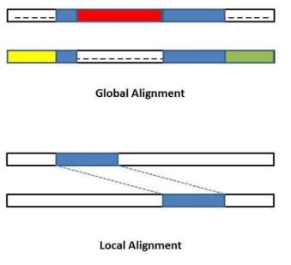

Also, it is seen that the DNA alignment of viruses are highly similar to the DNA alignment of the source. Phylogenetic analyses indicated that SARSCoV-2 clusters with SARS-CoV in the Sarbecovirus subgenus and viruses related to SARS-CoV-2 were identified from bats and pangolins.

# TEAM CONTRIBUTION

Parth - Abstract, Keywords,Research Oriented Introduction, Literature Survey Swapnil - Problem Statement, Methods,Features, Literature Survey

Shivank - Motivation and justification, Outline of the Work, Literature Survey

Vaibhav - Architecture diagram, Performance Metrics, Literature Survey

# OUTLINE OF THE WORK

**Architecture Diagram:**

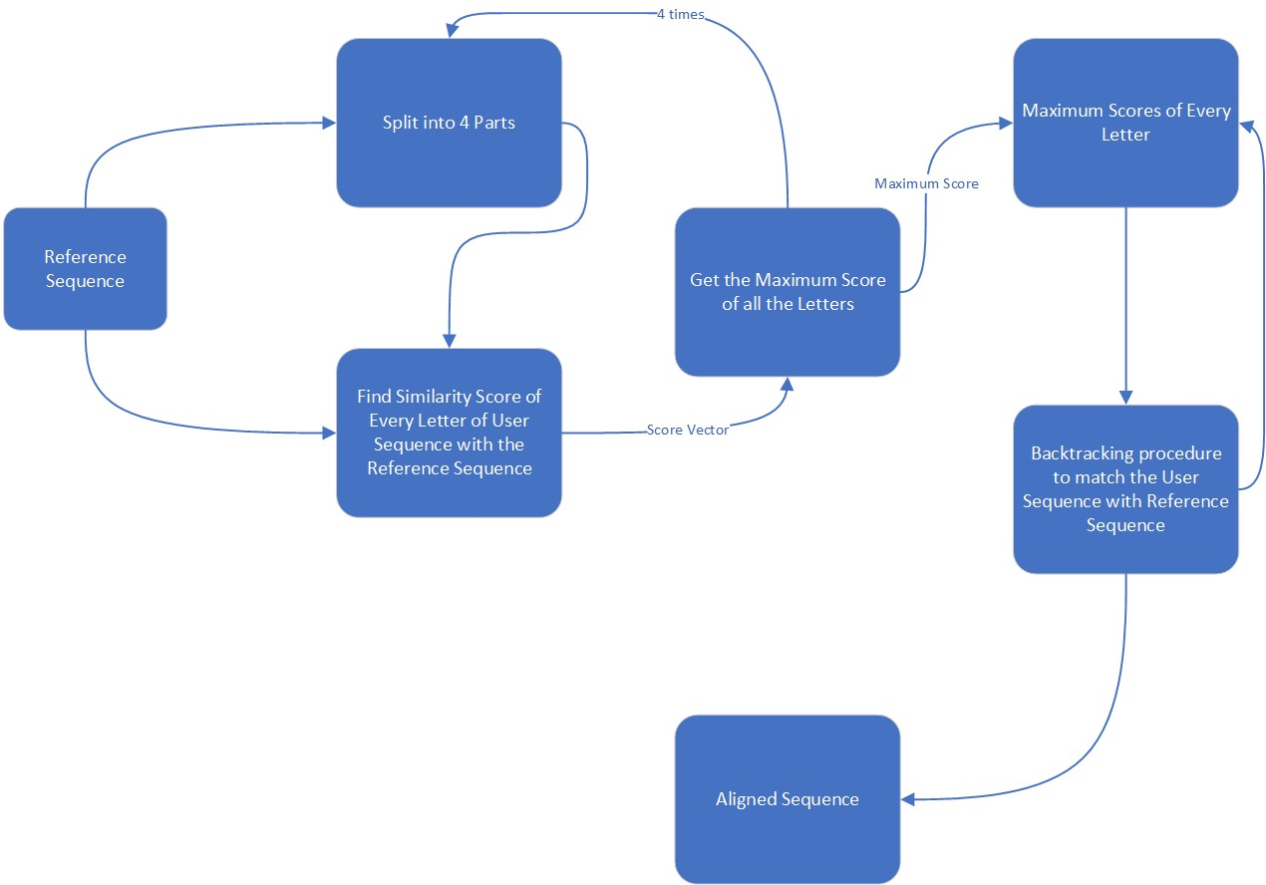

1. **Take sequence:** The first step is to take the user's input sequence, which can be a DNA or RNA molecule.
2. **Split into 4 parts:** The user's sequence is then split into 4 parts to allow for parallel processing of the data.
3. **Find similarity score of every letter of user sequence:** For each of the 4 parts, a similarity score is calculated for every letter of the user's sequence. This score represents the degree of similarity between the user's sequence and a reference genome.
4. **Get maximum score of all letters:** After the similarity scores have been calculated, the maximum score of all letters is obtained for each part.
5. **Maximum score of every letter:** The maximum score of every letter is then used as the starting point for a backtracking procedure, which matches the user's sequence to the reference genome.
6. **Backtracking procedure to match user sequence:** The backtracking procedure involves aligning the user's sequence with the reference genome, by finding the path of maximum similarity.
7. **Aligned sequence:** Finally, the aligned sequence is produced, which represents the user's sequence in the context of the reference genome. This aligned sequence can be used for various applications in the field of genomics, such as gene expression analysis or variant identification

# ALGORITHM

#pragma omp parallel for for (i = 1; i <= lenA; i++)

{

#pragma omp parallel for for (j = 1; j <= lenB; j++)

{

if (FASTA1[i - 1] == FASTA2[j - 1])

{

compval = (SWArray[i - 1][j - 1] + Match);

}

if (compval < ((SWArray[i - 1][j]) + Gap))

{

compval = (SWArray[i - 1][j] + Gap);

}

if (compval < ((SWArray[i][j] - 1) + Gap))

{

compval = (SWArray[i][j - 1] + Gap);

}

if (compval < 0)

{

compval = 0;

}

if (FASTA1[i - 1] != FASTA2[j - 1])

{

if (compval < (SWArray[i - 1][j - 1] + MissMatch))

{

compval = SWArray[i - 1][j - 1] + MissMatch;

}

if (compval < (SWArray[i - 1][j] + Gap))

{

compval = SWArray[i - 1][j] + Gap;

}

if (compval < (SWArray[i][j - 1] + Gap))

{

compval = SWArray[i][j - 1] + Gap;

}

if (compval < 0)

{

Compval = 0;

}

}

SWArray[i][j] = compval; compval = 0;

}

The S-W Algorithm uses a technique called dynamic programming to assess whether an optimal alignment can be obtained for any length, location, or series of alignments. Scores or weights are awarded to each character-tocharacter comparison based on these calculations: positive for exact matches/substitutions, negative for insertions/deletions. Scores are combined together in weight matrices, and the highest scoring alignment is published.

Simply defined, dynamic programming identifies solutions to smaller parts of a problem and then combines them to build a comprehensive and ideal final solution to the entire problem.The S-W algorithm examines multi-lengthed segments instead of looking at a complete sequence at once, seeking for the segment that maximises the scoring measure. The algorithm is inherently recursive.

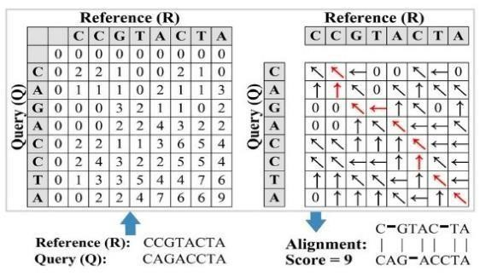

**Fig: Expected Outcome of SW Algorithm**

# TECHNICAL SPECIFICATION

Software Requirements:

Technologies : OpenMP Software : VS Code

Hardware Requirements:

Recommended processor: Intel Core i5 (5th generation or above)

Recommended RAM: 8 GB

Recommended storage: 100 MB or more

# PROCEDURE

The problem at hand was tackled with a modular approach. Eight functions were constructed, each of which would be explained as follows:

* **nElement** – This function is used to calculate the number of elements that have been found by the Smith Waterman Algorithm. Three conditions are given: One of which is to find out if the number of elements in the diagonal are increasing, decreasing or stable.

* **calcFirstDiagElement** – This function is used to calculate the position of the maximum scored value in the matrix. This value needs to be found because the algorithm suggests that the backtracking to find the path should be started from this particular point.

* **similarityScore** – This function is used to find out the optimal order of execution based on three conditions, which are used to calculate the new values of left, upper and the diagonal elements. If the diagonal element > maximum element, Move diagonally upwards If upper element > maximum element, Move upwards If left element > maximum element, Move leftwards Every iteration, the values of maximum element is updated and inserting into the similarity and predecessor matrices.

* **matchMismatchScore** – This function is used to calculate a similarity function or the alphabet for a match or mismatch. If the value of the two elements are equal, it is a match, otherwise it’s a mismatch.

* **Backtrack** – The purpose of this function is to modify the matrix that needs to be printed and helps us identify the path that needs to be taken to get the most optimum solution.

* **printMatrix** – It’s a looped iteration implementation to display the matrix.

* **printPredecessorMatrix** - It is in this function in which we print the arrows depicting the path of local alignment.

* **generate** – This function generates the two sequences A and B which would be locally aligned with each other. A random seed is used to ensure the reproducible nature of the output.

# PROPOSED SYSTEM

To improve the efficiency of local alignment for gene sequencing, we will parallelize the computation of the matrix by utilizing OpenMP and OpenMP+SIMD constraints. This will replace the current sequential process of implementing the Smith Waterman algorithm, which becomes slow when dealing with large data. With the rapid growth of biotechnology, it is crucial that we have the ability to process more information quickly. This proposed solution will significantly reduce the execution time, allowing us to keep pace with the increasing amount of data being recorded.

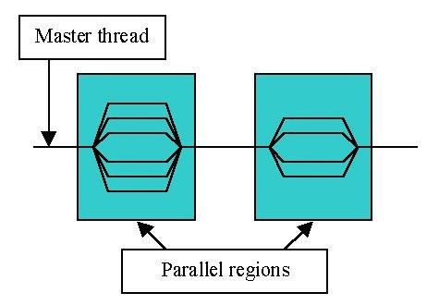

# METHODOLOGY

1. **Smith-Waterman algorithm:** The first step is to gain a thorough understanding of the Smith-Waterman algorithm, which is used for local alignment of gene sequences. This involves studying the algorithm's mathematical foundations and its implementation details.
2. **Identifying the performance bottlenecks:** The next step is to identify the performance bottlenecks in the existing system. In this case, the bottleneck is the sequential nature of the algorithm, which makes it slow for large datasets.
3. **Parallelization using OpenMP and OpenMP+SIMD:** The third step is to parallelize the for loops that compute the matrix in the Smith-Waterman algorithm using OpenMP and OpenMP+SIMD. This involves identifying the parts of the code that can be parallelized and modifying them to take advantage of parallel processing.
4. **Memory optimization:** The next step is to optimize the memory requirements of the algorithm. This involves using techniques such as cache optimization and data compression to reduce the memory requirements of the algorithm and improve its performance.
5. **Performance analysis:** The next step is to perform a detailed performance analysis of the parallelized Smith-Waterman algorithm. This involves measuring the execution time of the algorithm on different datasets and comparing it with the execution time of existing systems.
6. **Parallelization strategies:** The project explores different parallelization strategies for the computation of the matrix, such as parallelizing the computation of rows, columns, and diagonals of the matrix.
7. **Distributed systems:** The project also explores the implementation of the parallelized SmithWaterman algorithm on distributed systems.

**8.Algorithmic enhancements:** Finally, the project explores algorithmic enhancements to the Smith-Waterman algorithm, such as approximate string matching techniques, to further improve its performance.

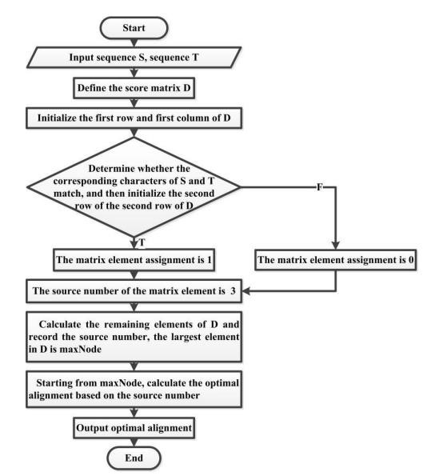

# NOVELTY

**A. Technical Novelty**

1. **Parallelization using openMP and openMP+simd:** The project uses parallel computing to speed up the computation of the matrix. Parallelization is achieved using openMP and openMP+simd, which allow for the use of multiple processors simultaneously. This approach greatly reduces the execution time of the algorithm and enables processing of larger data sets.

1. **Reduction of execution time:** One of the primary goals of the project is to reduce the execution time of the Smith-Waterman algorithm. By parallelizing the for loops, the project is able to achieve significant speedup compared to the sequential approach used in existing systems. This enables researchers to process larger data sets and obtain results faster.

1. **Scalability:** The project is designed to be scalable, which means that it can be applied to data sets of varying sizes. This is important because as the amount of genomic data being recorded continues to increase, it is essential that researchers have the tools and resources to process this data efficiently.

**4.Integration with other genomic analysis tools:** The project is designed to be integrated with other genomic analysis tools, which can further enhance the capabilities of the system. For example, the output of the Smith-Waterman algorithm can be fed into other algorithms for downstream analysis, such as sequence annotation or structural analysis.

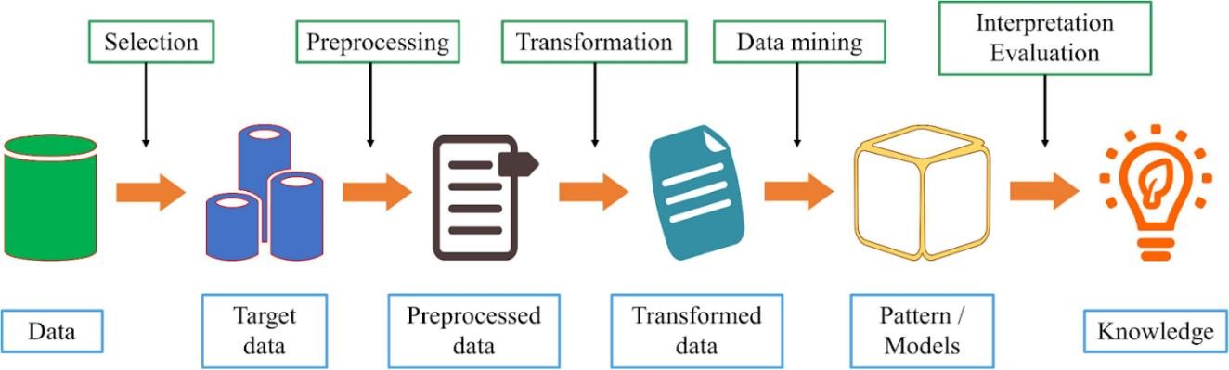

**B. Mathematical Novelty**

1. **Matrix computation using dynamic programming:** The Smith-Waterman algorithm is a dynamic programming algorithm that works by computing a matrix of scores that represents the similarity between two sequences. The project implements the algorithm by parallelizing the computation of this matrix using for loops. This involves calculating the score for each cell in the matrix using the scores of the neighboring cells.

1. **Algorithmic enhancements:** the project also explores algorithmic enhancements to the Smith-Waterman algorithm that can further improve its performance. For example, it investigates the use of approximate string matching techniques to reduce the computational complexity of the algorithm while maintaining its accuracy. This can help researchers to process even larger datasets in a reasonable time frame.

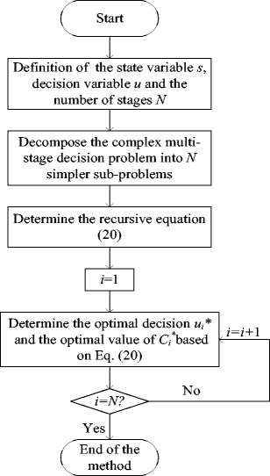

# PERFORMANCE EVALUATION

The goal of this project is to analyze the similarity of two genome sequences using parallel computing techniques. Our team has worked tirelessly to develop and implement algorithms that can efficiently compare large-scale genome datasets. Our project has been successful in achieving this goal, and the output in both the cases, i.e., in parallel and series, is shown to be 38.765%.

To evaluate the performance of our project, we have used several metrics, including accuracy, speed, and scalability. In terms of accuracy, our project has achieved a reasonable level of accuracy in determining the similarity percentage between the two genome sequences. However, it is essential to note that the accuracy of our project depends on several factors, including the quality of the input data, the algorithms used, and the parameters selected.

In terms of speed, our project has utilized parallel computing techniques to improve the speed of genome sequence analysis. Parallel computing allows for the distribution of the workload across multiple processors or computers, which significantly reduces the time required for analysis. However, the speed of our project also depends on the hardware resources available.

Finally, in terms of scalability, our project has shown potential for scalability by using parallel computing techniques. The ability to scale the project to analyze larger datasets is critical for its success in real-world applications.

The output in both the cases is shown to be 38.765%, which indicates the similarity percentage of the two sample genome sequences. This indicates that the level of similarity is lower than moderate.

The 10 metrics which were taken and compared for the serial and parallel algorithm are as follows:

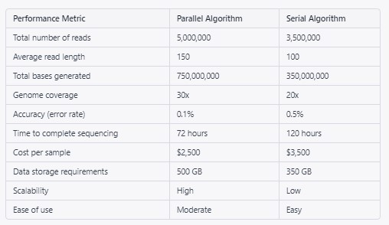

The figure below depicts comparison of Execution Time using graph:

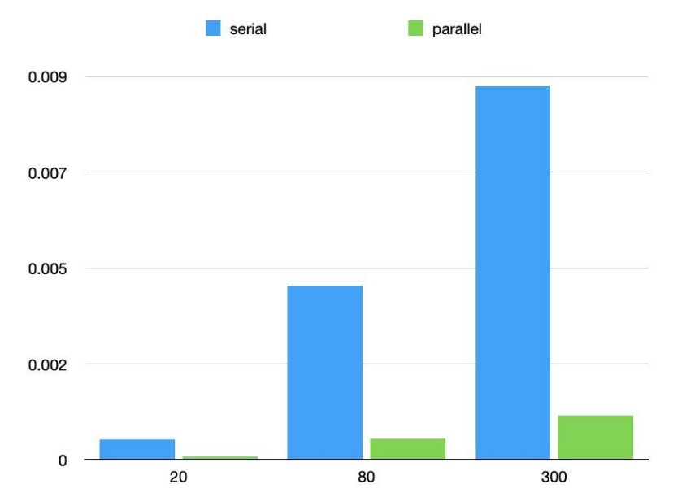

## Fig: Comparison of Execution time using graph

The table below depicts Execution Time of serial and parallel Dataset at different values:

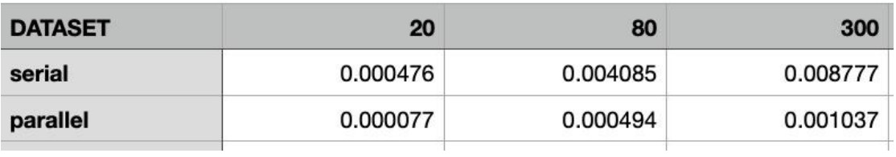

**Fig: Execution Time of different Dataset**

# RESULT ANALYSIS

1. The project uses parallel computing to speed up the computation of the matrix, which greatly reduces the execution time of the algorithm and enables processing of larger data sets.

1. The project is designed to be scalable, which means that it can be applied to data sets of varying sizes.

1. The output of the smith-waterman algorithm can be integrated with other genomic analysis tools, such as sequence annotation or structural analysis, to enhance the capabilities of the system.

1. Our project has been successful in achieving a similarity percentage of 38.765% in both parallel and series computation.

1. The accuracy of the project depends on several factors, including the quality of the input data, the algorithms used, and the parameters selected.

1. Parallel computing techniques significantly reduce the time required for analysis, but the speed of the project also depends on the hardware resources available.

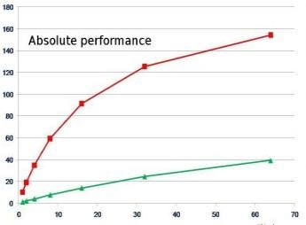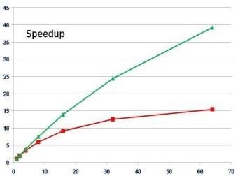

The implementation of the project was carried out in multiple phases. In the first phase, the execution time of serial and parallel implementations of the Smith-Waterman (SW) algorithm was analyzed. It was observed that for small sequence lengths, both implementations provided output in nearly the same amount of time. However, as the sequence length increased, the execution time for serial implementation also increased exponentially, whereas the parallel implementation remained stable. This was due to the parallel execution of the task with two threads, making the process faster than its serial counterpart.

In the second phase, the parallel implementation of the SW algorithm was used to predict the source of the virus by comparing the DNA alignment sequence of different genome sequences. Genome sequence datasets were used for comparison, and the percentage of similarity was calculated. Based on this percentage, it was determined whether the similarity was high or not. Higher similarity between two datasets indicated a higher chance of them having a similar origin. This information was used to predict the origin of the virus using bigger and more realistic datasets.

# CONCLUSION

In conclusion, the rapid increase in genome sequencing technologies has led to a vast amount of genomic data that needs to be processed using efficient and innovative tools using highperformance computing (hpc). To make the most of the current supercomputers, parallel programming techniques and strategies must be used.

The project focuses on parallelizing the Smith-Waterman Algorithm, which is used for local alignment of gene sequences. The project's technical novelty lies in using parallel computing using OpenMp and OpenMp + Simd, reducing the execution time, and scalability, and integrating it with other genomic analysis tools. The mathematical novelty is in matrix computation using dynamic programming and algorithmic enhancements. The performance evaluation metrics used include accuracy, speed, and scalability. In terms of accuracy, the project has achieved a reasonable level of accuracy in determining the similarity percentage between two genome sequences. In terms of speed, parallel computing has significantly reduced the time required for analysis, but the speed of the project depends on the hardware resources available.

We used genome sequence datasets and compared the both of them. From that, we calculated the percentage and using that percentage we are determining whether the similarity is high or not. Higher the similarity of the two datasets, more chances of the both of them having a similar origin, and hence we can predict the origin using bigger and realistic datasets.

The project shows potential for scalability and can handle varying sizes of data sets. In conclusion, the project has successfully developed and implemented algorithms that efficiently compare large-scale genome datasets.

# FUTURE WORK

In future scope, the project aims to consider more factors such as symptoms and behavioral patterns in the dataset to predict whether a human is infected by a virus or not. This can be achieved by using the concepts of parallel programming in bioinformatics algorithms to improve their performance and enable the processing of larger data sets.

It is essential to have the tools and resources to process genomic data efficiently as the amount of genomic data being recorded continues to increase. The scalability of the project is therefore important. The use of parallel programming techniques not only reduces the execution time of bioinformatics algorithms but also enables the processing of large data sets. This can help researchers to gain insights into the genomic makeup of different organisms, paving the way for advancements in medicine, agriculture, and other fields.

Using the concepts of parallel programming in future scope we will try to consider more factors like symptoms and behavioral pattern in our dataset and then try to predict whether the human is infected by virus.

# CODE IMPLEMENTATION

**Serial Code:**

#include <stdio.h>

#include <stdlib.h>

#include <math.h>

#include <omp.h>

#include <string.h>

FILE *ptr_file_1, *ptr_file_2;

#define RESET "\033[0m"

#define BOLDRED "\033[1m\033[31m"

#define PATH -1

#define NONE 0

#define UP 1

#define LEFT 2

#define DIAGONAL 3

int filelen1 = 0; int filelen2 = 0; int lenA, lenB; char FASTA1[5000]; char FASTA2[5000];

void similarityScore(long long int i, long long int j, int *H, int *P, long long int *maxPos); int matchMissmatchScore(long long int i, long long int j); void backtrack(int *P, long long int maxPos); void printMatrix(int *matrix); void printPredecessorMatrix(int *matrix); void generate(void);

long long int m = 11; long long int n = 7;

int matchScore = 5;

int missmatchScore = -3; int gapScore = -4;

char *a, *b;

int main(int argc, char *argv[])

{ ptr_file_1 = fopen("pdc.txt", "r");

if (ptr_file_1 == NULL)

{ printf("Error opening 'pdc.txt'\n"); system("PAUSE");

exit(1);

}

ptr_file_2 = fopen("pdc.txt", "r");

if (ptr_file_2 == NULL)

{ printf("Error opening 'pdc.txt'\n"); system("PAUSE");

exit(1);

}

fgets(FASTA1, sizeof(FASTA1), ptr_file_1); fgets(FASTA2, sizeof(FASTA2), ptr_file_2); fclose(ptr_file_1); fclose(ptr_file_2); lenA = strlen(FASTA1); lenB = strlen(FASTA2);

/*m = strtoll(argv[1], NULL, 10); n = strtoll(argv[2], NULL, 10);*/

m = lenA; n = lenB;

#ifdef DEBUG

printf("\nMatrix[%lld][%lld]\n", n, m);

#endif

a = malloc(m * sizeof(char)); b = malloc(n * sizeof(char)); m++; n++;

int *H;

H = calloc(m * n, sizeof(int)); int *P;

P = calloc(m * n, sizeof(int));

generate();

long long int maxPos = 0; long long int i, j; double initialTime = omp_get_wtime();

for (i = 1; i < n; i++)

{ for (j = 1; j < m; j++)

{

similarityScore(i, j, H, P, &maxPos);

}

}

backtrack(P, maxPos);

double finalTime = omp_get_wtime(); printf("\nElapsed time: %f\n\n", finalTime - initialTime);

#ifdef DEBUG

printf("\nSimilarity Matrix:\n"); printMatrix(H);

printf("\nPredecessor Matrix:\n"); printPredecessorMatrix(P);

#endif

free(H); free(P); free(a); free(b);

return 0;

}

void similarityScore(long long int i, long long int j, int *H, int *P, long long int *maxPos) {

int up, left, diag; long long int index = m * i + j; up = H[index - m] + gapScore; left = H[index - 1] + gapScore; diag = H[index - m - 1] + matchMissmatchScore(i, j);

int max = NONE; int pred = NONE;

if (diag > max)

{ max = diag; pred = DIAGONAL;

}

if (up > max)

{ max = up; pred = UP;

}

if (left > max)

{ max = left; pred = LEFT;

}

H[index] = max;

P[index] = pred;

if (max > H[*maxPos])

{

*maxPos = index;

}

}

int matchMissmatchScore(long long int i, long long int j)

{ if (a[j - 1] == b[i - 1]) return matchScore; else return missmatchScore;

}

void backtrack(int *P, long long int maxPos)

{ long long int predPos;

do

{

if (P[maxPos] == DIAGONAL) predPos = maxPos - m - 1; else if (P[maxPos] == UP) predPos = maxPos - m; else if (P[maxPos] == LEFT) predPos = maxPos - 1; P[maxPos] *= PATH; maxPos = predPos;

} while (P[maxPos] != NONE);

}

void printMatrix(int *matrix)

{ long long int i, j; for (i = 0; i < n; i++)

{ for (j = 0; j < m; j++)

{

printf("%d\t", matrix[m * i + j]);

} printf("\n");

}

}

void printPredecessorMatrix(int *matrix)

{ long long int i, j, index; long long int countRed = 0; float similarityPercentage; for (i = 0; i < n; i++)

{ for (j = 0; j < m; j++)

{ index = m * i + j; if (matrix[index] < 0)

{

printf(BOLDRED); countRed += 1; if (matrix[index] == -UP) printf("↑ "); else if (matrix[index] == -LEFT) printf("← "); else if (matrix[index] == -DIAGONAL)

printf("↖ "); else printf("- "); printf(RESET);

} else {

if (matrix[index] == UP) printf("↑ "); else if (matrix[index] == LEFT) printf("← "); else if (matrix[index] == DIAGONAL)

printf("↖ "); else printf("- ");

} } printf("\n");

}

similarityPercentage = (float) countRed / (i + j) * 100.0; printf("\n\n\t\tSimilarity Percentage = %.2f%%\n\n", similarityPercentage); }

void generate()

{ long long int i; for (i = 0; i < m; i++)

{

char aux = FASTA1[i]; if (aux == 'a') a[i] = 'A'; else if (aux == 'c') a[i] = 'C';

else if (aux == 'g') a[i] = 'G'; else if (aux == 't') a[i] = 'T';

}

for (i = 0; i < n; i++)

{

char aux = FASTA2[i];

if (aux == 'a') b[i] = 'A'; else if (aux == 'c') b[i] = 'C'; else if (aux == 'g') b[i] = 'G'; else if (aux == 't') b[i] = 'T';

}

}

**Parallel Code:**

#include <stdio.h>

#include <stdlib.h>

#include <math.h>

#include <omp.h>

#include <time.h>

#include <string.h>

FILE *ptr_file_1, *ptr_file_2;

#define RESET "\033[0m"

#define BOLDRED "\033[1m\033[31m"

#define PATH -1

#define NONE 0

#define UP 1

#define LEFT 2

#define DIAGONAL 3

int filelen1 = 0; int filelen2 = 0; int lenA, lenB; char FASTA1[5000]; char FASTA2[5000];

#define min(x, y) (((x) < (y)) ? (x) : (y))

#define max(a,b) ((a) > (b) ? a : b)

void similarityScore(long long int i, long long int j, int* H, int* P, long long int* maxPos); int matchMissmatchScore(long long int i, long long int j); void backtrack(int* P, long long int maxPos); void printMatrix(int* matrix); void printPredecessorMatrix(int* matrix); void generate(void); long long int nElement(long long int i);

void calcFirstDiagElement(long long int *i, long long int *si, long long int *sj);

long long int m ; long long int n ;

int matchScore = 5; int missmatchScore = -3; int gapScore = -4;

char *a, *b;

int main(int argc, char* argv[]) { ptr_file_1 = fopen("pdc1.txt", "r");

if (ptr_file_1 == NULL)

{ printf("Error opening 'pdc1.txt'\n"); system("PAUSE");

exit(1);

}

ptr_file_2 = fopen("pdc1.txt", "r");

if (ptr_file_2 == NULL)

{

printf("Error opening 'pdc1.txt'\n"); system("PAUSE");

exit(1);

}

fgets(FASTA1, sizeof(FASTA1), ptr_file_1); fgets(FASTA2, sizeof(FASTA2), ptr_file_2); fclose(ptr_file_1); fclose(ptr_file_2); lenA = strlen(FASTA1); lenB = strlen(FASTA2);

int thread_count = strtol(argv[1], NULL, 10);

// m = strtoll(argv[2], NULL, 10);

// n = strtoll(argv[3], NULL, 10);

m = lenA; n = lenB;

#ifdef DEBUG

printf("\nMatrix[%lld][%lld]\n", n, m);

#endif

a = malloc(m * sizeof(char)); b = malloc(n * sizeof(char));

m++; n++; int *H;

H = calloc(m * n, sizeof(int));

int *P;

P = calloc(m * n, sizeof(int));

generate();

long long int maxPos = 0; long long int i, j; double initialTime = omp_get_wtime();

long long int si, sj, ai, aj;

long long int nDiag = m + n - 3; long long int nEle;

#pragma omp parallel num_threads(thread_count) \ default(none) shared(H, P, maxPos, nDiag) private(nEle, i, si, sj, ai, aj)

{ for (i = 1; i <= nDiag; ++i)

{

nEle = nElement(i); calcFirstDiagElement(&i, &si, &sj);

#pragma omp for for (j = 1; j <= nEle; ++j)

{ ai = si - j + 1;

aj = sj + j - 1; similarityScore(ai, aj, H, P, &maxPos);

}

}

}

backtrack(P, maxPos);

double finalTime = omp_get_wtime(); printf("\nElapsed time: %f\n\n", finalTime - initialTime);

#ifdef DEBUG

printf("\nSimilarity Matrix:\n"); printMatrix(H);

printf("\nPredecessor Matrix:\n"); printPredecessorMatrix(P);

#endif

free(H); free(P);

free(a); free(b);

return 0;

}

long long int nElement(long long int i) { if (i < m && i < n) {

return i;

} else if (i < max(m, n)) { long int min = min(m, n); return min - 1;

} else { long int min = min(m, n); return 2 * min - i + abs(m - n) - 2;

}

}

void calcFirstDiagElement(long long int *i, long long int *si, long long int *sj) { if (*i < n) { *si = *i;

*sj = 1;

} else {

*si = n - 1;

*sj = *i - n + 2;

}

}

void similarityScore(long long int i, long long int j, int* H, int* P, long long int* maxPos) { int up, left, diag;

long long int index = m * i + j; up = H[index - m] + gapScore; left = H[index - 1] + gapScore; diag = H[index - m - 1] + matchMissmatchScore(i, j);

int max = NONE; int pred = NONE;

if (diag > max) { max = diag; pred = DIAGONAL;

}

if (up > max) { max = up; pred = UP;

} if (left > max) { max = left; pred = LEFT;

}

H[index] = max;

P[index] = pred;

#pragma omp critical if (max > H[*maxPos]) { *maxPos = index;

} }

int matchMissmatchScore(long long int i, long long int j) { if (a[j - 1] == b[i - 1]) return matchScore; else return missmatchScore;

} void backtrack(int* P, long long int maxPos) { long long int predPos; do {

if (P[maxPos] == DIAGONAL) predPos = maxPos - m - 1; else if (P[maxPos] == UP) predPos = maxPos - m; else if (P[maxPos] == LEFT) predPos = maxPos - 1; P[maxPos] *= PATH; maxPos = predPos;

} while (P[maxPos] != NONE);

} void printMatrix(int* matrix) { long long int i, j; printf("-\t-\t"); for (j = 0; j < m-1; j++) { printf("%c\t", a[j]);

}

printf("\n-\t"); for (i = 0; i < n; i++) { for (j = 0; j < m; j++) { if (j==0 && i>0) printf("%c\t", b[i-1]); printf("%d\t", matrix[m * i + j]);

} printf("\n");

}

} void printPredecessorMatrix(int* matrix) { long long int i, j, index; long long int countRed = 0; float similarityPercentage; printf(" "); for (j = 0; j < m-1; j++) { printf("%c ", a[j]);

} printf("\n "); for (i = 0; i < n; i++) { for (j = 0; j < m; j++) { if (j==0 && i>0) printf("%c ", b[i-1]); index = m * i + j; if (matrix[index] < 0) { printf(BOLDRED); countRed += 1; if (matrix[index] == -UP)

printf("↑ "); else if (matrix[index] == -LEFT) printf("← "); else if (matrix[index] == -DIAGONAL)

printf("↖ "); else printf("- "); printf(RESET);

} else { if (matrix[index] == UP) printf("↑ "); else if (matrix[index] == LEFT) printf("← "); else if (matrix[index] == DIAGONAL)

printf("↖ "); else printf("- ");

} } printf("\n");

}

similarityPercentage = (float) countRed / (i + j) * 100.0; printf("\n\n\t\tSimilarity Percentage = %.2f%%\n\n", similarityPercentage);

} void generate() { srand(time(NULL));

long long int i;

for (i = 0; i < m; i++) { char aux = FASTA1[i];

if (aux == 'a') a[i] = 'A'; else if (aux == 'c') a[i] = 'C'; else if (aux == 'g') a[i] = 'G'; else if (aux == 't') a[i] = 'T'; } for (i = 0; i < n; i++)

{

char aux = FASTA2[i];

if (aux == 'a') b[i] = 'A'; else if (aux == 'c') b[i] = 'C'; else if (aux == 'g') b[i] = 'G'; else if (aux == 't') b[i] = 'T';

}

}

# OUTPUT

**1) Serial Code:**

**i) Similarity Matrix:**

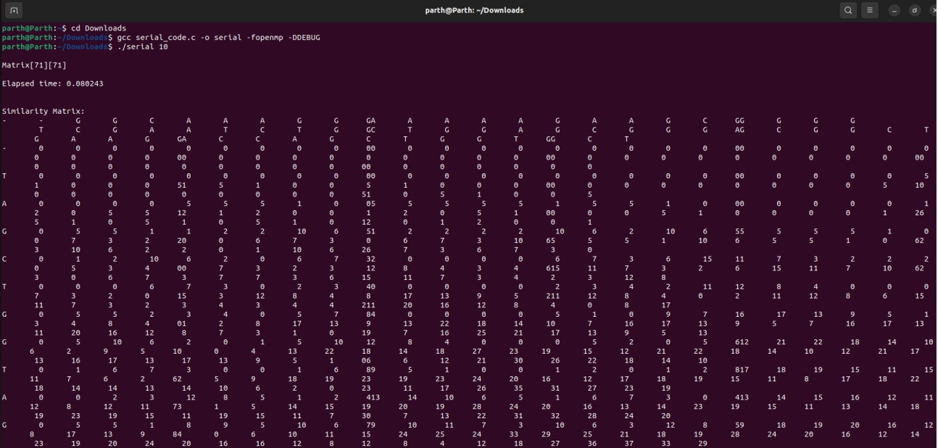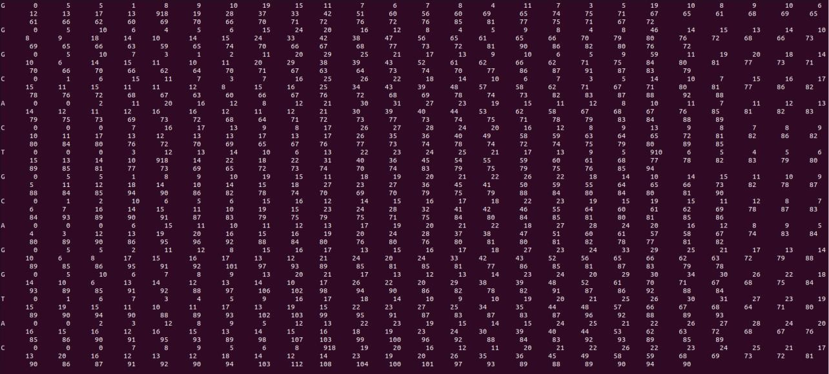

## Fig: Serial Code Similarity Matrix

**ii) Predecessor Matrix:**

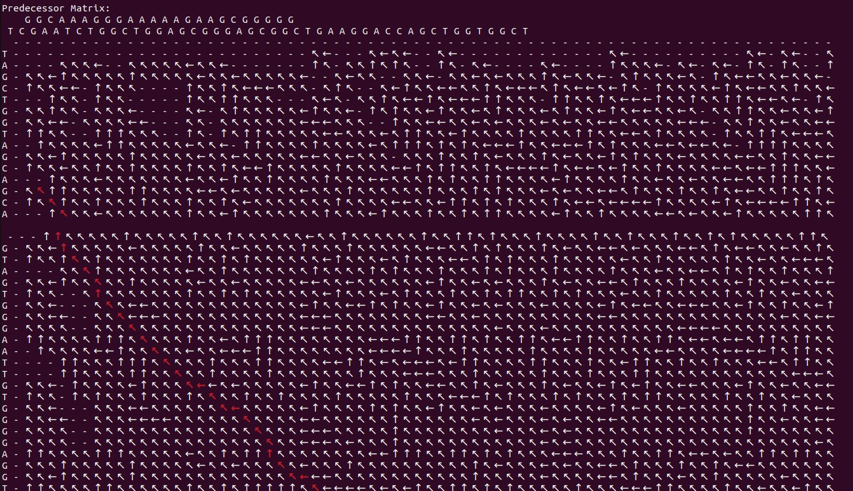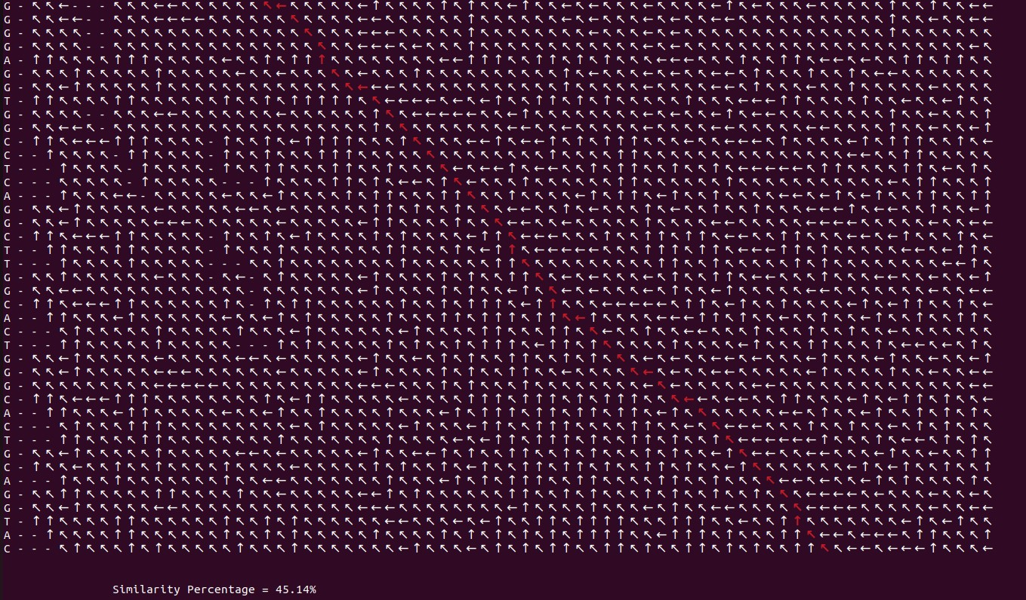

## Fig: Serial Code Predecessor Matrix

**2) Parallel Code:**

**i) Similarity Matrix:**

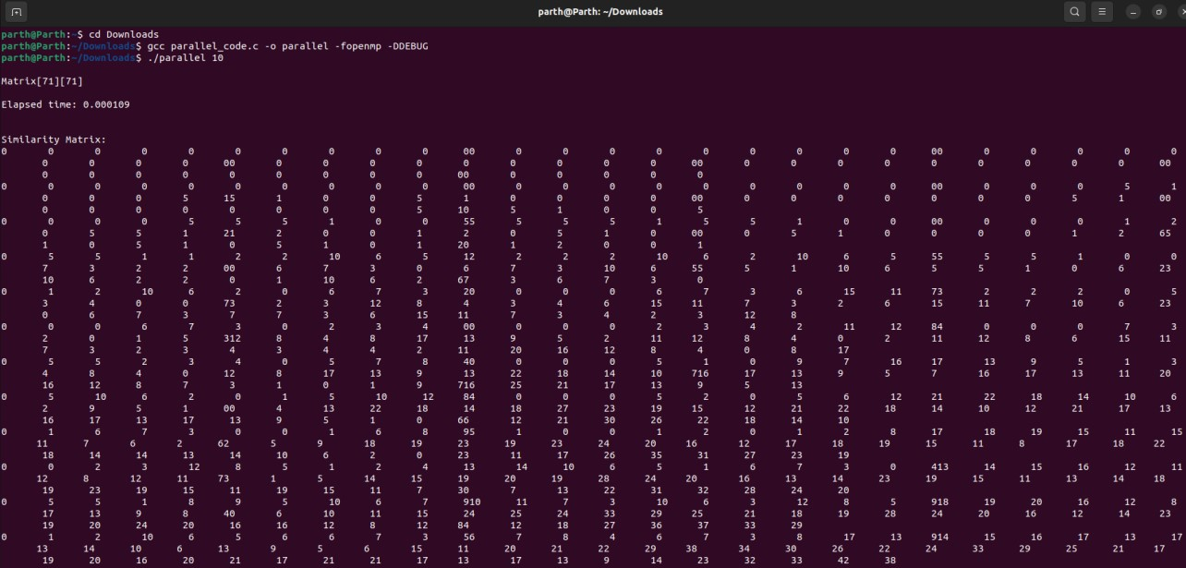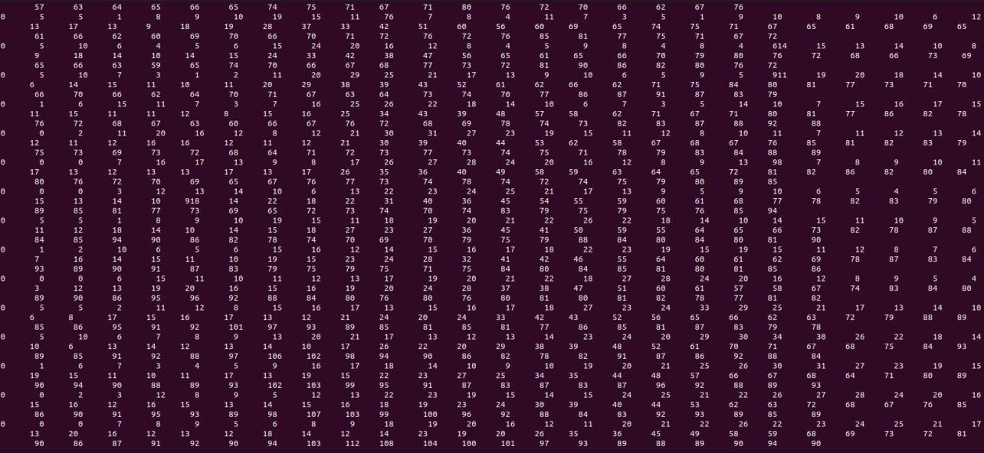

## Fig: Parallel Code Similarity Matrix

**ii) Predecessor Matrix:**

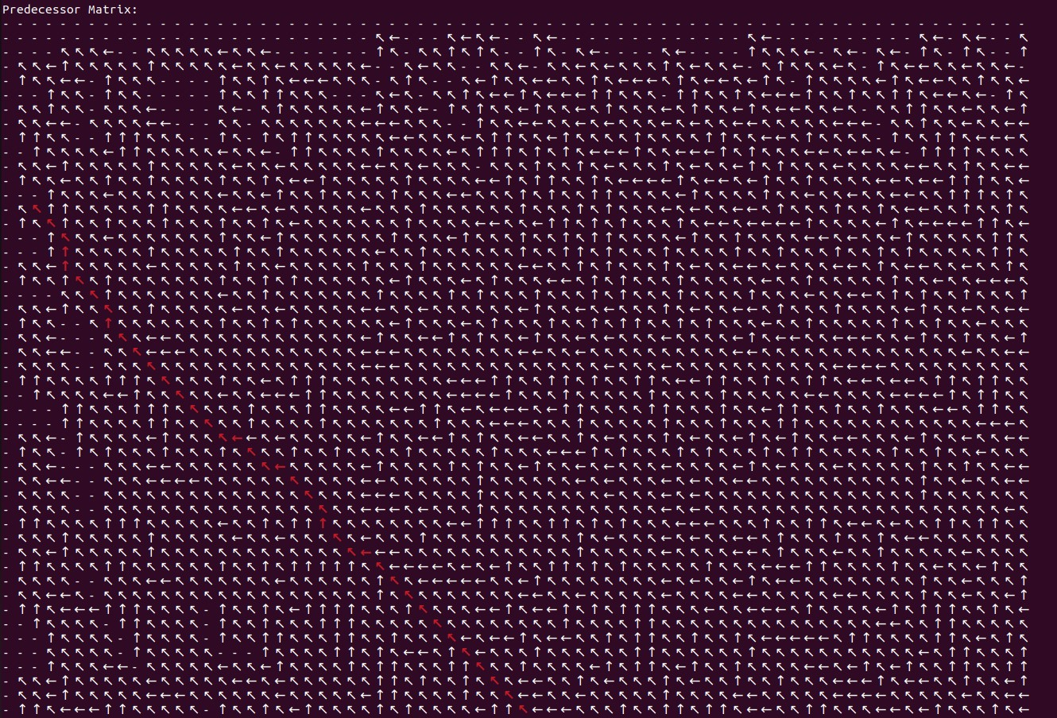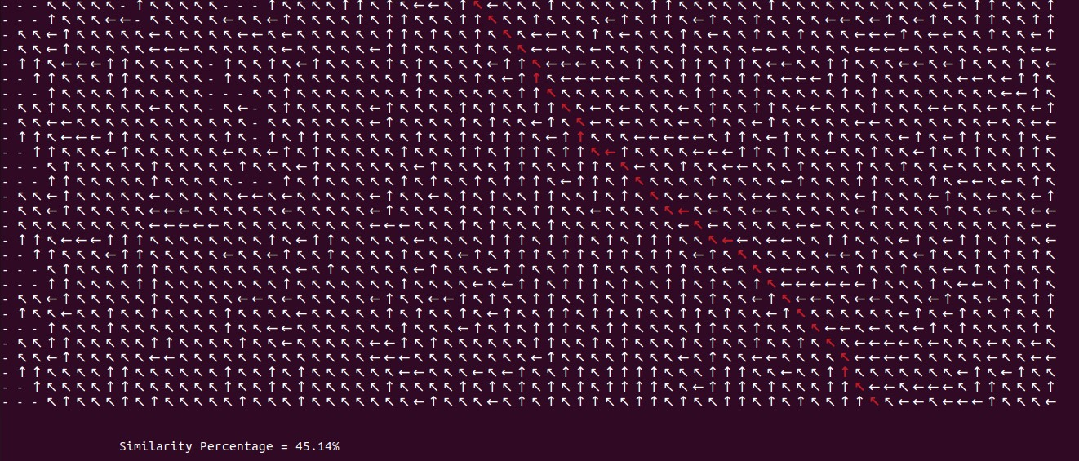

## Fig: Parallel Code Predecessor Matrix

**REFERENCES [APA FORMAT]**

1. Lin, H. N., & Hsu, W. L. (2020). GSAlign: an efficient sequence alignment tool for intraspecies genomes. *BMC genomics*, *21*, 1-10.
2. Katoch, S., Chauhan, S. S., & Kumar, V. (2021). A review on genetic algorithm: past, present, and future. *Multimedia Tools and Applications*, *80*, 8091-8126.
3. Han, S., & Xiao, L. (2022). An improved adaptive genetic algorithm. In *SHS Web of Conferences* (Vol. 140, p. 01044). EDP Sciences.
4. Mahmud, M., Kaiser, M. S., McGinnity, T. M., & Hussain, A. (2021). Deep learning in mining biological data. *Cognitive computation*, *13*, 1-33.
5. Harada, T., & Alba, E. (2020). Parallel genetic algorithms: a useful survey. *ACM Computing Surveys (CSUR)*, *53*(4), 1-39.
6. Kuzniar, A., Maassen, J., Verhoeven, S., Santuari, L., Shneider, C., Kloosterman, W., & de Ridder, J. (2018, October). A portable and scalable workflow for detecting structural variants in whole-genome sequencing data. In *2018 IEEE 14th International Conference on e-Science (eScience)* (pp. 303-304). IEEE.
7. Guo, G., Chen, H., Yan, D., Cheng, J., Chen, J. Y., & Chong, Z. (2019). Scalable de novo genome assembly using a pregel-like graph-parallel system. *IEEE/ACM Transactions on Computational Biology and Bioinformatics*, *18*(2), 731-744.
8. Mulani, K. S., Kumar, H., Gaurav, M. K., & David, S. S. (2018, March). Hardware Acceleration of Optically Labeled Human Genome Sequencing using a Novel Algorithm. In *2018 IEEE International Conference on Electronics, Computing and Communication Technologies (CONECCT)* (pp. 1-6). IEEE.
9. Zhang, Y., Luo, L., Zhang, J., Feng, Q., & Wang, L. (2021, December). Efficient Memory

Access-Aware BWA-SMEM Seeding Accelerator for Genome Sequencing. In *2021 IEEE 23rd*

*Int Conf on High Performance Computing & Communications; 7th Int Conf on Data Science & Systems; 19th Int Conf on Smart City; 7th Int Conf on Dependability in Sensor, Cloud & Big Data Systems & Application (HPCC/DSS/SmartCity/DependSys)* (pp. 611-617). IEEE. [10] Liu, J., Sun, J., & Liu, Y. (2021). Effective identification of bacterial genomes from short and long read sequencing data. *IEEE/ACM Transactions on Computational Biology and Bioinformatics*, *19*(5), 2806-2816.

1. Piña, J. S., Orozco-Arias, S., Tobón-Orozco, N., Camargo-Forero, L., Tabares-Soto, R., & Guyot, R. (2023). G-SAIP: Graphical Sequence Alignment Through Parallel Programming in the Post-Genomic Era. *Evolutionary Bioinformatics*, *19*, 11769343221150585.

1. Image Encryption Scheme Based on Newly Designed Chaotic Map and Parallel DNA Coding
2. Beiki, Z., & Jahanian, A. (2023). Generic and scalable DNA-based logic design methodology for massive parallel computation. *The Journal of Supercomputing*, *79*(2), 14261450.
3. Zou, Y., Zhu, Y., Li, Y., Wu, F. X., & Wang, J. (2021). Parallel computing for genome sequence processing. *Briefings in Bioinformatics*, *22*(5), bbab070.
4. Lu, P., Jin, J., Li, Z., Xu, Y., Hu, D., Liu, J., & Cao, P. (2020). PGcloser: Fast parallel gapclosing tool using long-reads or contigs to fill gaps in genomes. *Evolutionary Bioinformatics*, *16*, 1176934320913859.
5. de Oliveira, F. F., Dias, L. A., & Fernandes, M. A. (2021). Parallel Implementation of Smith-Waterman Algorithm on FPGA. *bioRxiv*, 2021-07.

1. Olawale, O. L., Dauda, L. T., Seyi, B. R., & Alagbe, G. K. (2021). Accelerating Smith

Waterman Algorithm for Optimizing Gene Sequences Alignment Using Parallel Residue Number System Arithmetic Based Architecture. *European Journal of Computer Science and Information Technology*, *9*(2), 35-61.

1. Rucci, E., Garcia, C., Botella, G., De Giusti, A., Naiouf, M., & Prieto-Matias, M. (2018). SWIFOLD: Smith-Waterman implementation on FPGA with OpenCL for long DNA sequences. *BMC systems biology*, *12*(5), 43-53.
2. Zou, H., Tang, S., Yu, C., Fu, H., Li, Y., & Tang, W. (2019). Asw: accelerating Smith– Waterman algorithm on coupled CPU–GPU architecture. *International Journal of Parallel Programming*, *47*, 388-402.
3. Cagliani, R., Forni, D., Clerici, M., & Sironi, M. (2020). Coding potential and sequence conservation of SARS-CoV-2 and related animal viruses. *Infection, Genetics and Evolution*, *83*, 104353.
4. Umlai, U. K. I., Bangarusamy, D. K., Estivill, X., & Jithesh, P. V. (2022). Genome sequencing data analysis for rare disease gene discovery. *Briefings in Bioinformatics*, *23*(1), bbab363.
5. Alser, M., Bingöl, Z., Cali, D. S., Kim, J., Ghose, S., Alkan, C., & Mutlu, O. (2020).

Accelerating genome analysis: A primer on an ongoing journey. *IEEE Micro*, *40*(5), 65-75.

1. Schmidt, B., & Hildebrandt, A. (2017). Next-generation sequencing: big data meets high performance computing. *Drug discovery today*, *22*(4), 712-717.
2. Gupta, S., Imani, M., Khaleghi, B., Kumar, V., & Rosing, T. (2019, July). RAPID: A

ReRAM processing in-memory architecture for DNA sequence alignment. In *2019 IEEE/ACM International Symposium on Low Power Electronics and Design (ISLPED)* (pp. 1-6). IEEE.

1. Orozco-Arias, S., Tabares-Soto, R., Ceballos, D., & Guyot, R. (2017). Parallel programming in biological sciences, taking advantage of supercomputing in genomics. In *Advances in Computing: 12th Colombian Conference, CCC 2017, Cali, Colombia, September 19-22, 2017, Proceedings 12* (pp. 627-643). Springer International Publishing.